- Program ID : VB002MA1

- Display Layout
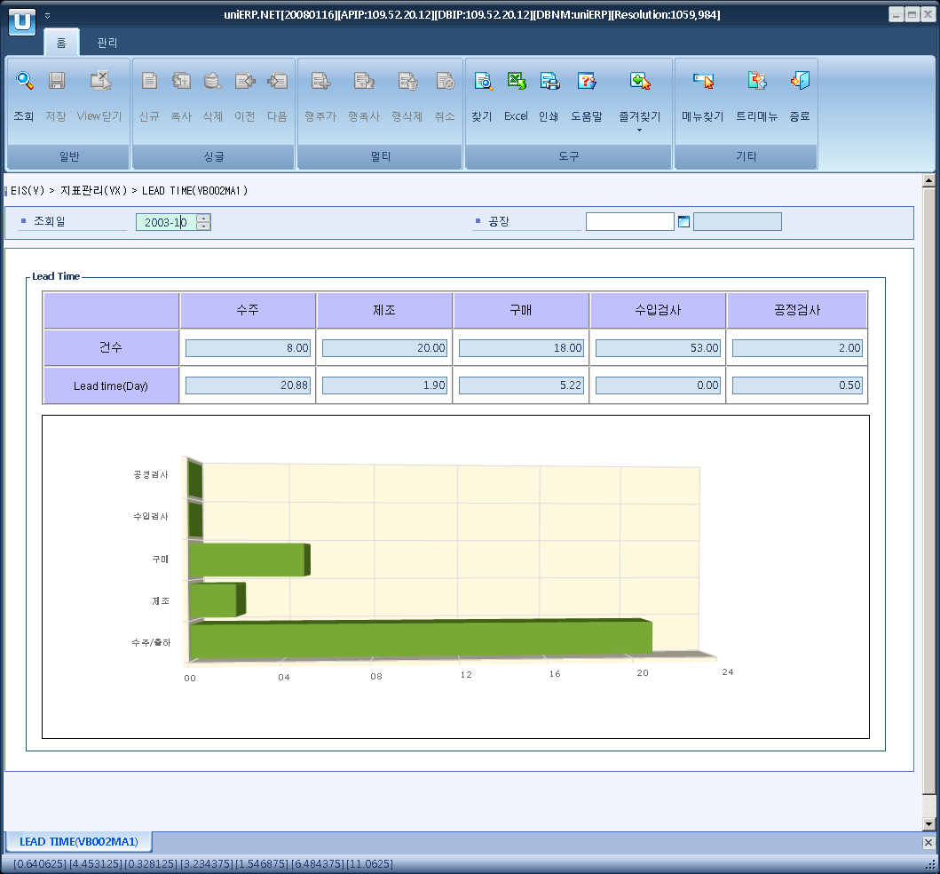
- Event flow
- Click Query button
- OnFncQuery -> DbQuery -> DataChange
- Display Unit combo change
- uniCombo1_ValueChanged -> DataChange

- SQL Statements
- The amount of orders received
SELECT VB0020T.TOT_CNT, VB0020T.LT_DAY
FROM VB0020T
WHERE VB0020T.SP_ID = @strSpId
AND VB0020T.YYYYMM = @strYYYYMM
AND VB0020T.INDEX_CD = 'B01'

- production
SELECT VB0020T.TOT_CNT, VB0020T.LT_DAY
FROM VB0020T
WHERE VB0020T.SP_ID = @strSpId
AND VB0020T.YYYYMM = @strYYYYMM
AND VB0020T.INDEX_CD = 'B02'

- purchase
SELECT VB0020T.TOT_CNT, VB0020T.LT_DAY
FROM VB0020T
WHERE VB0020T.SP_ID = @strSpId
AND VB0020T.YYYYMM = @strYYYYMM
AND VB0020T.INDEX_CD = 'B03'

- Incomming Inspection
SELECT VB0020T.TOT_CNT, VB0020T.LT_DAY
FROM VB0020T
WHERE VB0020T.SP_ID = @strSpId
AND VB0020T.YYYYMM = @strYYYYMM
AND VB0020T.INDEX_CD = 'B04'

- Operation Inspection
SELECT VB0020T.TOT_CNT, VB0020T.LT_DAY
FROM VB0020T
WHERE VB0020T.SP_ID = @strSpId
AND VB0020T.YYYYMM = @strYYYYMM
AND VB0020T.INDEX_CD = 'B05'

- Planned production - yesterday
SELECT ISNULL(SUM(order_qty_in_base_unit), 0)
FROM p_production_order_header
WHERE plan_compt_dt = DATEADD(DD, -1, @strDate)

- production output - month
SELECT ISNULL(SUM(a.prod_qty_in_base_unit), 0)
FROM p_production_results a
INNER JOIN p_production_order_detail b
ON a.prodt_order_no = b.prodt_order_no
AND a.opr_no = b.opr_no
AND b.rout_order IN ('S','L')
WHERE a.report_dt >= LEFT(@strDate, 6) + '01'
AND a.report_dt < CONVERT(VARCHAR(6) ,DATEADD(MM, 1, @strDate), 112)
AND a.del_flg = 'N'

- production output - yesterday
SELECT ISNULL(SUM(a.prod_qty_in_base_unit), 0)
FROM p_production_results a
INNER JOIN p_production_order_detail b
ON a.prodt_order_no = b.prodt_order_no
AND a.opr_no = b.opr_no
AND b.rout_order IN ('S','L')
WHERE a.report_dt = DATEADD(DD, -1, @strDate)
AND a.del_flg = 'N'

- bad goods - yesterday
SELECT ISNULL(SUM(P_PRODUCTION_RESULTS.INSP_BAD_QTY_IN_BASE_UNIT + CASE WHEN P_PRODUCTION_RESULTS.REPORT_TYPE = 'B' THEN P_PRODUCTION_RESULTS.PROD_QTY_IN_BASE_UNIT ELSE 0 END), 0)
FROM P_PRODUCTION_RESULTS, P_PRODUCTION_ORDER_DETAIL
WHERE P_PRODUCTION_RESULTS.PRODT_ORDER_NO = P_PRODUCTION_ORDER_DETAIL.PRODT_ORDER_NO
AND P_PRODUCTION_RESULTS.OPR_NO = P_PRODUCTION_ORDER_DETAIL.OPR_NO
AND P_PRODUCTION_RESULTS.REPORT_DT = DATEADD (DD, -1, @strDate)
AND P_PRODUCTION_ORDER_DETAIL.ROUT_ORDER IN ('S','L')
AND P_PRODUCTION_RESULTS.DEL_FLG = 'N'

